Exercise: Writing a Data Management Plan

Looking at example plans

- There are two example DMPs in your pack: one technical appendix submitted to the AHRC and a social science plan submitted to the ESRC. Depending on your research area, skim through one or both to get a sense of what to write.

- Discuss with your partner or in small groups what you like about the plan(s) and would replicate.

Drafting your own

- Read through the DCC Checklist for a Data Management Plan concertina leaflet. This has a panel for each of the common themes addressed in DMPs.
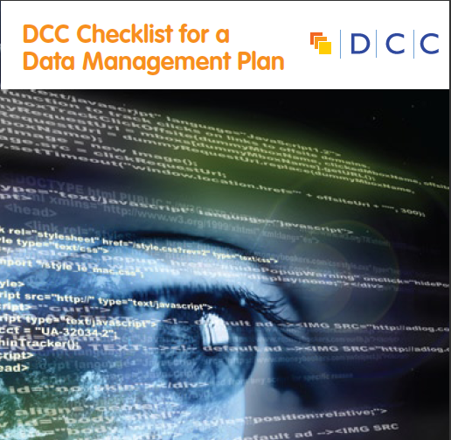
- Pick one of the themes (e.g. data collection, ethics and legal compliance, data sharing) and draft a response to the questions based on your own research

- Share your ideas with your partner / group to discuss

